**High Lift Prediction Workshop I – Fluids 2012 Special Sessions**

**Grid Generation**

This series of grids for the High Lift Prediction Workshop I are of the Trap Wing geometry with brackets and a hemispherical farfield. Unstructured volumes were generated with tets only and with a combination of tets and prisms. Both types of meshes are clustered to the surface grids for boundary layer resolution.

There is roughly a factor of 3 between each grid (coarse, medium, fine) presented in this study. Details of cell types, totals and point counts are shown below:

|  |  |  |  |  |  |  |
| --- | --- | --- | --- | --- | --- | --- |
| Grid | Pyramids | Tetrahedra | Prisms | Total Cell  Count | Total Point  Count | % Reduction |
| CoarseTrapWing-Brackets _Tets  (Aniso and Iso Tets) |  | 16,406,610 |  | 16,406,610 | 2,782,000 |  |
| MediumTrapWing-Brackets _Tets  (Aniso and Iso Tets) |  | 48,347,976 |  | 48,347,976 | 8,146,915 |  |
| FineTrapWing-Brackets _Tets  (Aniso and Iso Tets) |  | 141,509,667 |  | 144,458,007 | 24,232,815 |  |
|  |  |  |  |  |  |  |
| CoarseTrapWing-Brackets_TetsPrisms  (Aniso Tets, Iso Tets, Prisms) | 113,278 | 1,570,378 | 4,869,892 | 6,553,548 | 2,782,000 | 60.0 |
| MediumTrapWing-Brackets_TetsPrisms  (Aniso Tets, Iso Tets, Prisms) | 244,863 | 3,572,175 | 14,762,025 | 18,579,063 | 8,146,915 | 61.5 |
| FineTrapWing-Brackets_TetsPrisms  (Aniso Tets, Iso Tets, Prisms) | 386,410 | 23,493,668 | 40,063,863 | 63,943,941 | 24,232,815 | 55.7 |

**Boundary Conditions**

The boundary conditions were applied as seen below:

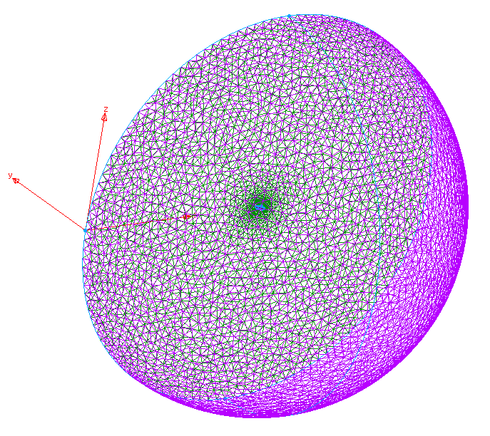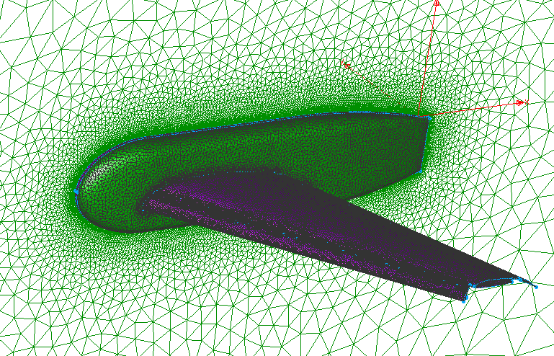

**Symmetry BC**

**Symmetry BC**

**Wall BC**

**Farfield BC**

**Available Solver Formats**

Grids were exported in 5 solver formats:

* CGNS
* UGRID
* USM3D
* CFD++
* STAR-CCM+

Each solver has its own .tar.gz file containing the six grids:

|  |  |
| --- | --- |
| Archive File | Contents |
| HLPW1-Brackets-CGNS.tar.gz | * + CoarseTrapWing-Brackets-Tets.cgns   + CoarseTrapWing-Brackets-TetsPrisms.cgns   + MediumTrapWing-Brackets-Tets.cgns   + MediumTrapWing-Brackets-TetsPrisms.cgns   + FineTrapWing-Brackets-Tets.cgns   + FineTrapWing-Brackets-TetsPrisms.cgns |
| HLPW1-Brackets-UGRID.tar.gz | * + CoarseTrapWing-Brackets-TetsPrisms.mapbc   + CoarseTrapWing-Brackets-TetsPrisms.ugrid   + CoarseTrapWing-Brackets-Tets.mapbc   + CoarseTrapWing-Brackets-Tets.ugrid   + MediumTrapWing-Brackets-TetsPrisms.mapbc   + MediumTrapWing-Brackets-TetsPrisms.ugrid   + MediumTrapWing-Brackets-Tets.mapbc   + MediumTrapWing-Brackets-Tets.ugrid   + FineTrapWing-Brackets-TetsPrisms.mapbc   + FineTrapWing-Brackets-TetsPrisms.ugrid   + FineTrapWing-Brackets-Tets.mapbc   + FineTrapWing-Brackets-Tets.ugrid |
| HLPW1-Brackets-USM3D.tar.gz | * + CoarseTrapWing-Brackets-Tets.bc   + CoarseTrapWing-Brackets-Tets.cogsg   + CoarseTrapWing-Brackets-Tets.mapbc   + MediumTrapWing-Brackets-Tets.bc   + MediumTrapWing-Brackets-Tets.cogsg   + MediumTrapWing-Brackets-Tets.mapbc   + FineTrapWing-Brackets-Tets.bc   + FineTrapWing-Brackets-Tets.cogsg   + FineTrapWing-Brackets-Tets.mapbc |
| HLPW1-Brackets-CFD++.tar.gz  (directory structure and example of file listing) | * + CoarseTrapWing-Brackets-Tets     - cellsin.bin     - cgrpsin.bin.1     - exbcsin.bin     - mcfd.bc     - mcfd.grp     - nodesin.bin   + CoarseTrapWing-Brackets-TetsPrisms   + MediumTrapWing-Brackets-Tets   + MediumTrapWing-Brackets-TetsPrisms   + FineTrapWing-Brackets-Tets   + FineTrapWing-Brackets-Tets Prisms |
| HLPW1-Brackets-STAR-CCM+.tar.gz | * + CoarseTrapWing-Brackets-Tets.ccm   + CoarseTrapWing-Brackets-TetsPrisms.ccm   + MediumTrapWing-Brackets-Tets.ccm   + MediumTrapWing-Brackets-TetsPrisms.ccm   + FineTrapWing-Brackets-Tets.ccm   + FineTrapWing-Brackets-TetsPrisms.ccm |